13.2 Editors - Video Sequence Editor - Tool Shelf
Tool shelf in Preview view 1
Sample 1
Annotate Tools group 2
Annotate 2
Tool Settings 2
Color 2
Stabilize Stroke 2
Radius 2
Factor 2
Annotate Line 2
Tool Settings 2
Color 3
Style Start 3
End 3
Annotate Polygon 3
Tool Settings 3
Color 3
Annotate Eraser 3
Tool Settings 4
Radius 4
Tool shelf in Sequencer view 4
Select 4
Blade 4
Active Tool settings 4
Last operator Split Strips 4
Frame 4
Channel 4
Type 4
Use Cursor Position 4
Side 4

Tool shelf in Preview view
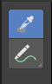
The strip menu contains strip related functionality.

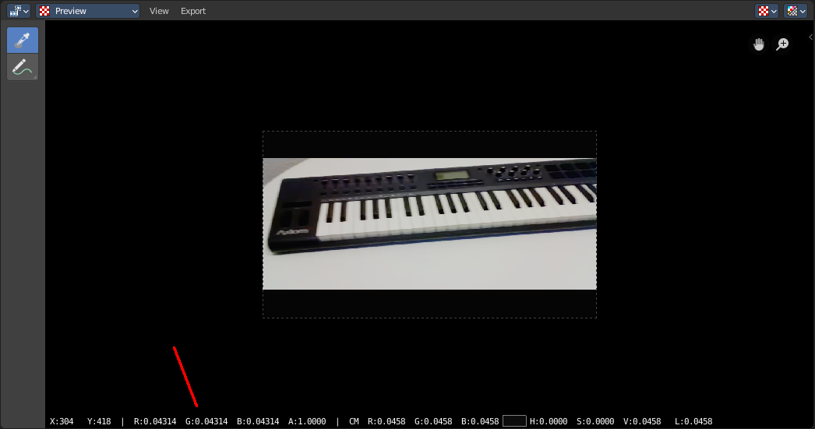
Sample
Samples colors under the mouse position when you left click at the position. The result is displayed at the bottom of the view.

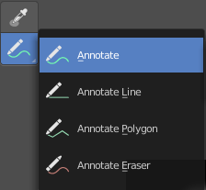
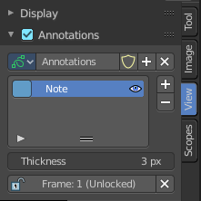
Annotate Tools group
The annotation tool is available in multiple editors. With this tool you can write notes at the screen. The annotate tools is the little brother of the grease pencil objects.
Further settings for annotate can be found in the sidebar. Here you can also remove an annotation when you don't longer need it. And here you can also adjust the size of the stroke.
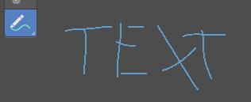

Annotate
Draw free-hand strokes in the main window.

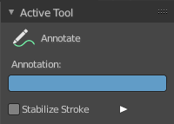
Tool Settings
The tool settings for Annotate.

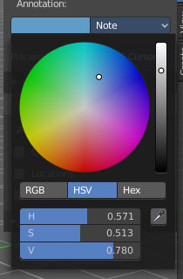
Color
Clicking at the left color field reveals a color picker. Define the color for the annotation stroke.

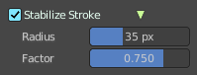
Stabilize Stroke
Helper to draw smooth and clean lines. Pressing shift inverts the effect.

Radius
The radius for the stroke stabilization.

Factor
Stabilizer stroke factor. Higher values gives a smoother stroke.

Annotate Line
Click and drag to create a line.

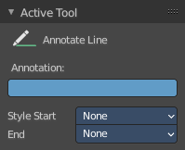
Tool Settings
The tool settings for the Annotate tool.

Color
Clicking at the left color field reveals a color picker. Define the color for the annotation stroke.

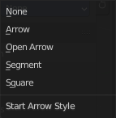
Style Start
The stroke start style. With an arrow for example you place an arrow at the start of the stroke.

End
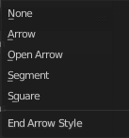
The stroke end style. With an arrow for example you place an arrow at the end of the stroke.

Annotate Polygon
Click multiple times to create multiple connected lines. The current polygon is finished when Esc or RMB is pressed.

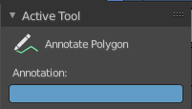
Tool Settings
The tool settings for Annotate.

Color
Clicking at the left color field reveals a color picker where you can define the color for the annotation stroke.


Annotate Eraser
Click and drag to remove annotate lines.

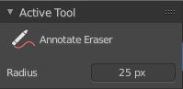
Tool Settings

Radius
The radius of the eraser pencil.

Tool shelf in Sequencer view

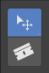
Select
Select strips. This default mode allows you to select strips and move them around.

Blade
Cut the selected strips at mouse position.

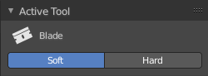
Active Tool settings
Create a soft split or a hard split.

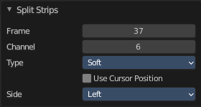
Last operator Split Strips

Frame
The frame at which the cut happens.

Channel
The channel of the strip.

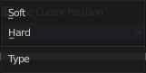
Type
How to cut. Soft or hard.

Use Cursor Position
Split at the position of the cursor instead of the current frame. Note! This setting makes no sense. You can't adjust the cursor position afterwards.

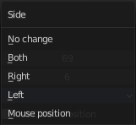
Side
The side that remains selected after the split.

